## Luna

1. 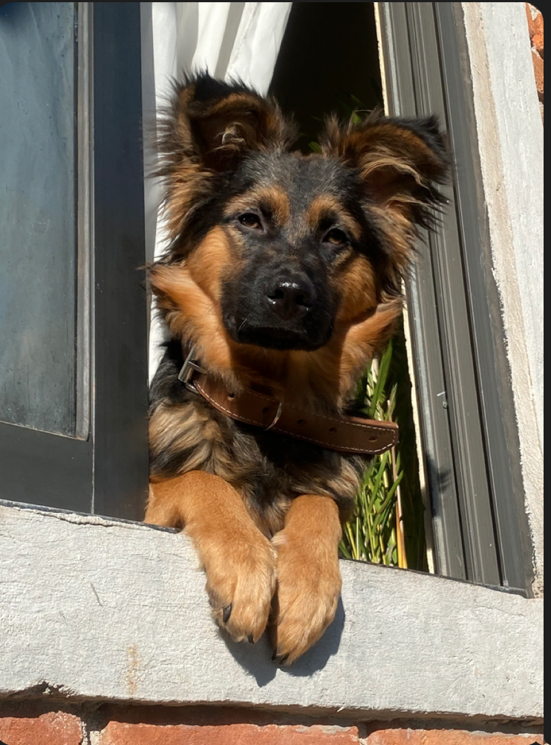
2. Luna.PNG
3. Mini German shepherd sunbathing
4. Luna is a German shepherd mix and a fireball of energy. Oftentimes, destroying anything in her path she will take and hide all your socks, shoes, and clothes for her to chew on. She loves playing catch at the park, it always gives her the zoomies.
5. Luna is a very jealous, loving, and protective dog. She really embraces her inner chihuahua and will bark at any stranger, car, or noise at night. She makes the perfect guard dog. But she is not at all aggressive. Luna is all bark no bite!

For the next four pictures you can just put the names of the files, you don't have to include the files in this drive, but you do need to add them to the proper Google Drive.

1. **Photo Gallery – (Just write Photo Gallery)**
2. luna_puppy.PNG
3. Luna as a puppy
4. luna_napping.PNG
5. Luna’s afternoon nap
6. luna_friends.PNG
7. Luna, Lobi, Laith
8. luna_evil.PNG
9. Luna death stare
10. **Likes – (Just write Likes)**
11. Chicken
12. Park
13. Belly Rubs
14. Jahaira Flores